SMART ARM

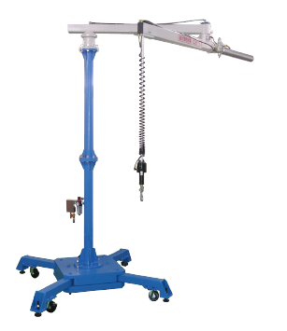
Ergonomic and Zero Gravity load balancing and lifting is always a biggest challenge for both customers and manufacturers. In Arhan Technologies Pvt. Ltd. Joint hand with San-Ei-Seiki, Japan for overcome this challenge.

With combine study, designing and understanding of use requirement we proudly present SMART ARM, solution of Ergonomic problems. This Arm operates as external human hand and operator do not feel any load for any application. SMART ARM can work as fast as human or user capability.

SMART ARM work on load cell based weight balancing mechanism with zero intervention of electrical supply. System is purely pneumatic which allow 100% duty cycle, 27 x 7, 365 Days.

SAY NO TO Production delay, Operation fatigue, Repetitive setting of weight, Safety hazard & Maintenance.
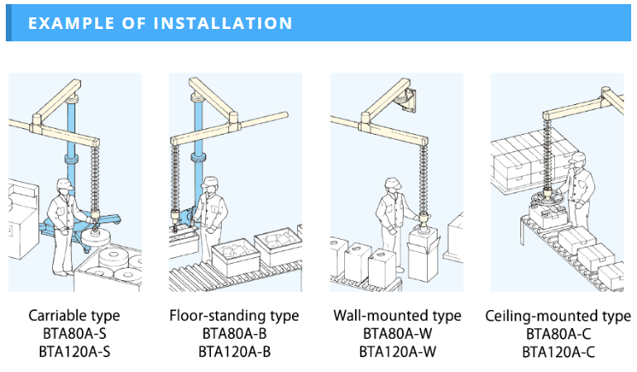
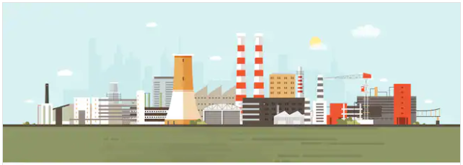
Smart arm is best suitable to handle multiple weights with extremely low Push-Pull and Up-Down force on high production line. This product has Pneumatic Load cell, which adjust Air Pressure as per working load once just lifted. Full vertical (1500mm) travel range, low head room and hook type load cell allow this product to fit nearly all type gripper, location and applications.

Features/ Advantages :

- Push-Pull Force – 1 to 1.5 Kg
- Up and Down Force – Up to 0.5 Kg
- No Need to Operate Pendent
- Full Length Floating – 1500mm
- Industrial Safety – No Jerking or Unsafe Operation
- User can directly handle Job, No need to push and pull Load Cell after lifting
- Capacity – Up to 120 Kg (80 Kg and 120 Kg models are available)
- Working Range – Overhead, Floor Standing, Mobile type
- Low Head Room – 155 mm only (Conventional System require minimum height of 450mm)
- Simplify The Skilled Operations – No Need for skilled User
- Manufacturing – With Std. Design and Own manufacturing setup
- Hold Position – Job can be hold at any point
- Load Cell – Pneumatic and Robust Design for low Maintenance Cost
- No need to give external electrical supply
- Gripper – Can be interlink with any type of gripper like Hook, Vacuum, Clapping etc
